**Exercise 1: Control Structures**

**Scenario 1: The bank wants to apply a discount to loan interest rates for customers above 60 years old.**

* + **Question: Write a PL/SQL block that loops through all customers, checks their age, and if they are above 60, apply a 1% discount to their current loan interest rates.**

**Scenario 2: A customer can be promoted to VIP status based on their balance.**

* + **Question: Write a PL/SQL block that iterates through all customers and sets a flag IsVIP to TRUE for those with a balance over $10,000.**

**Scenario 3: The bank wants to send reminders to customers whose loans are due within the next 30 days.**

* + **Question: Write a PL/SQL block that fetches all loans due in the next 30 days and prints a reminder message for each customer.**

**Code :**

CREATE TABLE customers (

  customer_id    NUMBER PRIMARY KEY,

  customer_name  VARCHAR2(50),

  age            NUMBER,

  balance        NUMBER(10, 2),

  isVIP          VARCHAR2(5),  -- 'TRUE' or 'FALSE'

  loan_id        NUMBER

);

CREATE TABLE loans (

  loan_id        NUMBER PRIMARY KEY,

  customer_id    NUMBER,

  interest_rate  NUMBER(5, 2),

  due_date       DATE

);

INSERT INTO customers VALUES (101, 'Alice Johnson', 65, 15000.00, 'FALSE', 201);

INSERT INTO customers VALUES (102, 'Bob Smith', 45, 8000.00, 'FALSE', 202);

INSERT INTO customers VALUES (103, 'Charlie Brown', 70, 12000.00, 'FALSE', 203);

INSERT INTO customers VALUES (104, 'Daisy Thomas', 35, 11000.00, 'FALSE', 204);

INSERT INTO customers VALUES (105, 'Edward Clark', 62, 9500.00, 'FALSE', 205);

INSERT INTO loans VALUES (201, 101, 7.5, SYSDATE + 10);

INSERT INTO loans VALUES (202, 102, 8.0, SYSDATE + 45);

INSERT INTO loans VALUES (203, 103, 6.5, SYSDATE + 25);

INSERT INTO loans VALUES (204, 104, 7.0, SYSDATE + 5);

INSERT INTO loans VALUES (205, 105, 7.8, SYSDATE - 10);

SELECT * FROM customers;

SELECT * FROM loans;

BEGIN

  FOR cust IN (

    SELECT c.customer_id, c.customer_name, c.age, l.loan_id, l.interest_rate

    FROM customers c

    JOIN loans l ON c.customer_id = l.customer_id

    WHERE c.age > 60

  ) LOOP

    UPDATE loans

    SET interest_rate = cust.interest_rate - 1

    WHERE loan_id = cust.loan_id;

    DBMS_OUTPUT.PUT_LINE(' Interest rate updated for Customer ID: ' || cust.customer_id ||

                         ', Name: ' || cust.customer_name);

  END LOOP;

END;

/

BEGIN

  FOR cust IN (

    SELECT customer_id, customer_name, balance

    FROM customers

    WHERE balance > 10000

  ) LOOP

    UPDATE customers

    SET isVIP = 'TRUE'

    WHERE customer_id = cust.customer_id;

    DBMS_OUTPUT.PUT_LINE(' Customer ' || cust.customer_name ||

                         ' (ID: ' || cust.customer_id ||

                         ') promoted to VIP. Balance: $' || cust.balance);

  END LOOP;

END;

/

DECLARE

  CURSOR due_loans IS

    SELECT l.loan_id, l.due_date, c.customer_name

    FROM loans l

    JOIN customers c ON l.customer_id = c.customer_id

    WHERE l.due_date BETWEEN SYSDATE AND SYSDATE + 30;

BEGIN

  FOR loan_rec IN due_loans LOOP

    DBMS_OUTPUT.PUT_LINE('Reminder: Loan ID ' || loan_rec.loan_id ||

                         ' for ' || loan_rec.customer_name ||

                         ' is due on ' || TO_CHAR(loan_rec.due_date, 'DD-MON-YYYY'));

  END LOOP;

END;

/

**Output:**

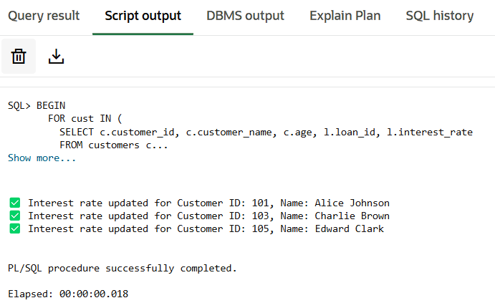**Scenario 1:**

**Scenario 2:**

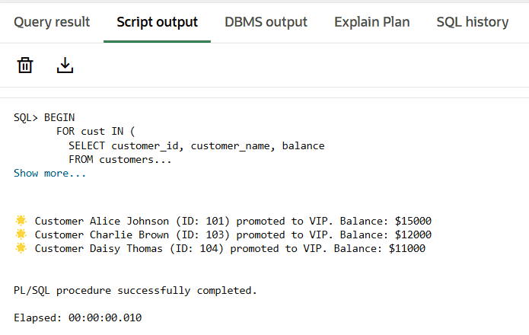

**Scenario 3:**

